BizTrack360 — Aqdas Branch Artifacts
Branch: database | Responsibility: Database / Data Layer

Purpose of This File
This file contains the SRS artifacts most directly connected to system entities, relationships, data stores, data flows, task records and structured information management.

Source
This file is derived from the submitted BizTrack360 Software Requirements Specification (SRS). The artifact descriptions and diagrams below preserve the SRS terminology and content.

Branch Artifact List
- 1. Class Diagram
- 2. Contextual Level DFD
- 3. Level 1 DFD
- 4. Level 2 DFD — Task Management Data Flow

1. Class Diagram

Purpose / Description
Defines the structural organization of the BizTrack360 system and the core entities/classes that support data storage.

Detailed Artifact Content from the SRS
- User is the central entity and contains identity, contact, authentication and role information.
- Administrator, Manager, Employee and Investor are user types with specialized functions.
- Department represents organizational divisions.
- Task stores task descriptions, deadlines and progress.
- KPI measures performance and productivity.
- FinancialRecord stores income and expenditure information.
- Document supports secure file storage and version management.
- Meeting handles meeting scheduling and information.
- Notification manages alerts and reminders.
- ActivityLog records user actions for accountability and tracking.
- Core classes listed in the SRS include User, Stakeholder, Business, Department, Task, KPI, Financial Record, Document and Meeting.
- Business contains stakeholders.
- Users belong to departments.
- Tasks are assigned to users.
- KPIs evaluate tasks.

Related SRS Requirements
- Authorized business data must be stored and accessible.
- Documents and sensitive data must be securely stored.
- All system activities must be traceable through logs.
- The system requires a database for structured data storage.

Original Diagram from SRS (Page 17)
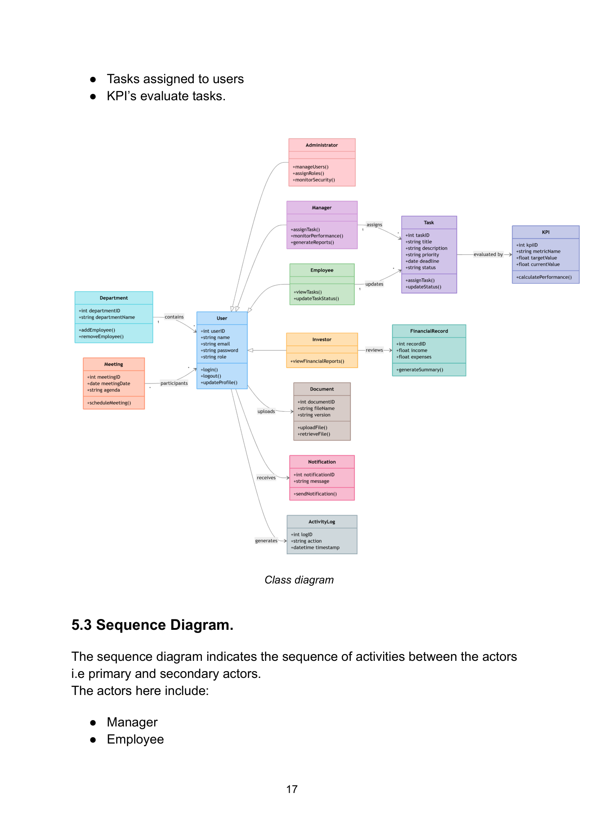

2. Contextual Level DFD

Purpose / Description
Shows BizTrack360 as one integrated system and the major external actors exchanging information with it.

Detailed Artifact Content from the SRS
- BizTrack360 is represented as one integrated platform.
- Administrator manages users, permissions and security.
- Business Owner monitors performance and reviews financial information.
- Managers allocate tasks and supervise workflow.
- Employees access assigned tasks, update progress and retrieve documents.
- Investors receive limited business insights and financial summaries.
- The diagram establishes the high-level boundaries and data exchanges of the system.

Related SRS Requirements
- Users must be authenticated before accessing the system.
- Access must be restricted according to user roles/permissions.
- Task information, progress and status must be stored and tracked.
- System activities must be traceable through activity logs.
- Sensitive data and files must be securely stored.

Original Diagram from SRS (Page 19)
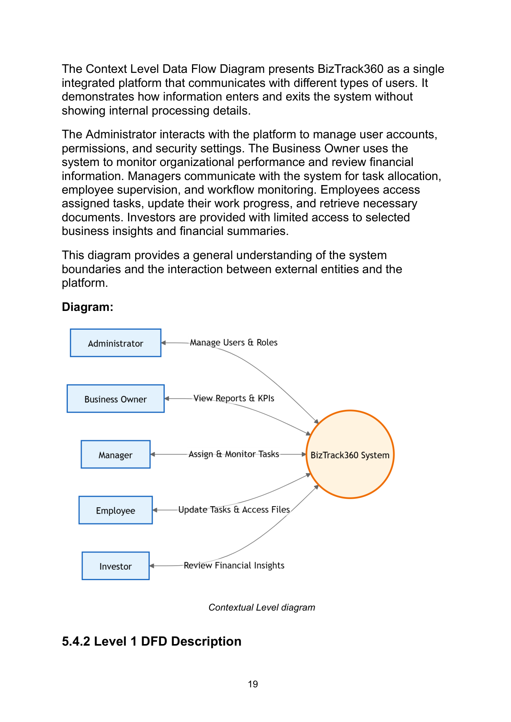

3. Level 1 DFD

Purpose / Description
Breaks the system into major functional modules and shows the data-processing structure at a higher level of detail.

Detailed Artifact Content from the SRS
- User and Role Management.
- Task Management.
- Performance Monitoring.
- Financial Overview.
- Document Management.
- Meeting Management.
- Notification Service.
- Activity Logging.
- These modules represent the main processing areas through which information is handled and stored.

Related SRS Requirements
- Users must be authenticated before accessing the system.
- Access must be restricted according to user roles/permissions.
- Task information, progress and status must be stored and tracked.
- System activities must be traceable through activity logs.
- Sensitive data and files must be securely stored.

Original Diagram from SRS (Page 20)
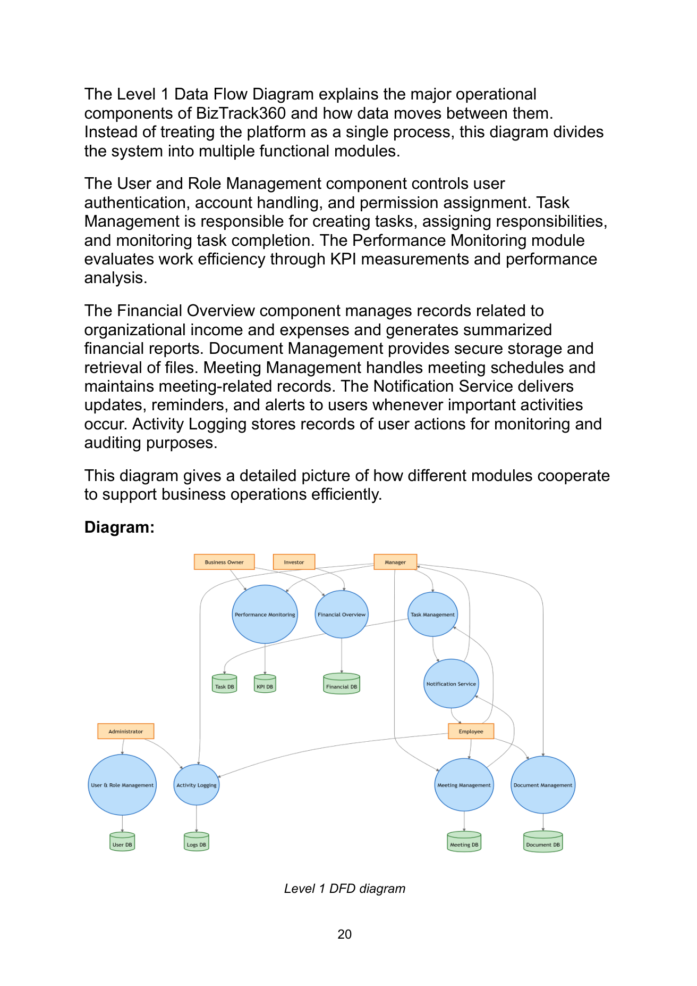

4. Level 2 DFD — Task Management Data Flow

Purpose / Description
Provides detailed task-management data flow useful for designing task-related database records and update operations.

Detailed Artifact Content from the SRS
- Manager enters task priority, deadline and description.
- System stores task information in the task database.
- Notification informs employees after assignment.
- Employee retrieves tasks and submits progress updates.
- Updated task information is stored.
- Manager monitors progress and reviews completion status.

Related SRS Requirements
- Users must be authenticated before accessing the system.
- Access must be restricted according to user roles/permissions.
- Task information, progress and status must be stored and tracked.
- System activities must be traceable through activity logs.
- Sensitive data and files must be securely stored.

Original Diagram from SRS (Page 21)
